Genome Sciences Purchase Path Training Guide

The web purchasing system is a software package that facilitates all the purchasing needs of the department through a paperless, online system. The software manages al aspects of purchasing including order submittal, approval, receiving, tracking, and history. It is a multi-user, multi-tiered system that provides flexibility to departments to setup multiple organizational divisions and units, each with their own methods of submitting, tracking and approving orders.

The online purchasing system is not an interface to the UW purchasing & ordering system and it is not a direct interface to vendors. Rather the web purchasing system is for use internal of a department.

User Types
This section outlines the two different user types for each Lab or Unit.
- Unit Purchasing Submitters – A user at this level has the ability to submit an order for a unit. They also control the ordering within their unit and who is purchasing requesters within their unit. Examples of Purchasing Submitters would be unit managers or people who approve a unit’s purchase.
- Unit Purchasing Requester – A user at this level can start an order. They do not have the ability to submit the order nor change any other line items other than those they created. Examples of Purchasing Requesters would be unit employees.

Order Overview
States of an Order
- Not Submitted to Purchasing – This state indicates that an order has been started by the unit, but has yet to be submitted to division purchasing agents.
- Awaiting Approval – This state indicates an order has been submitted for purchase, but has yet to be approved by a division level approver.
- Request Submitted – This state indicates the order is ready to be purchased. All approval has been received and the purchasing agent can start to process the order.
- PO # Assigned – This state indicates the purchasing agent has assigned a PO # to this order.
- Ordered: Not yet received – This state indicates that the purchasing agent has completed ordering the product with the vendor, but the unit has not yet received the product.
- Ordered: Some items received– This state indicates that the unit has received some items, but there are still outstanding items.
- Ordered: All Items received – This state indicates that the unit has received all items.
- Closed – This state indicates the order has been placed, products have been received, and the order is finished.

Logging on to the System
To access this system go to the following URL: http://purchasing.pathology.washington.edu
Only person’s with Requesting or Submitting authority will be allowed access to this system.
When you first access the system, you will be asked to provide a username and password to identify yourself. After you have entered your username and password you will be presented with a screen asking you what account you want to use. For most people, you will have only one choice here. However, it is possible to be a member of multiple units and have multiple accounts and/or levels of access. If you have multiple accounts, choose from the dropdown box which account you would like to use for this session.

If you do not have access or are having trouble access this system, please contact the Fiscal Office FOEGE SOUTH S250. You may also use the forms locate in S250. Fill them out and return them to S250 for processing.

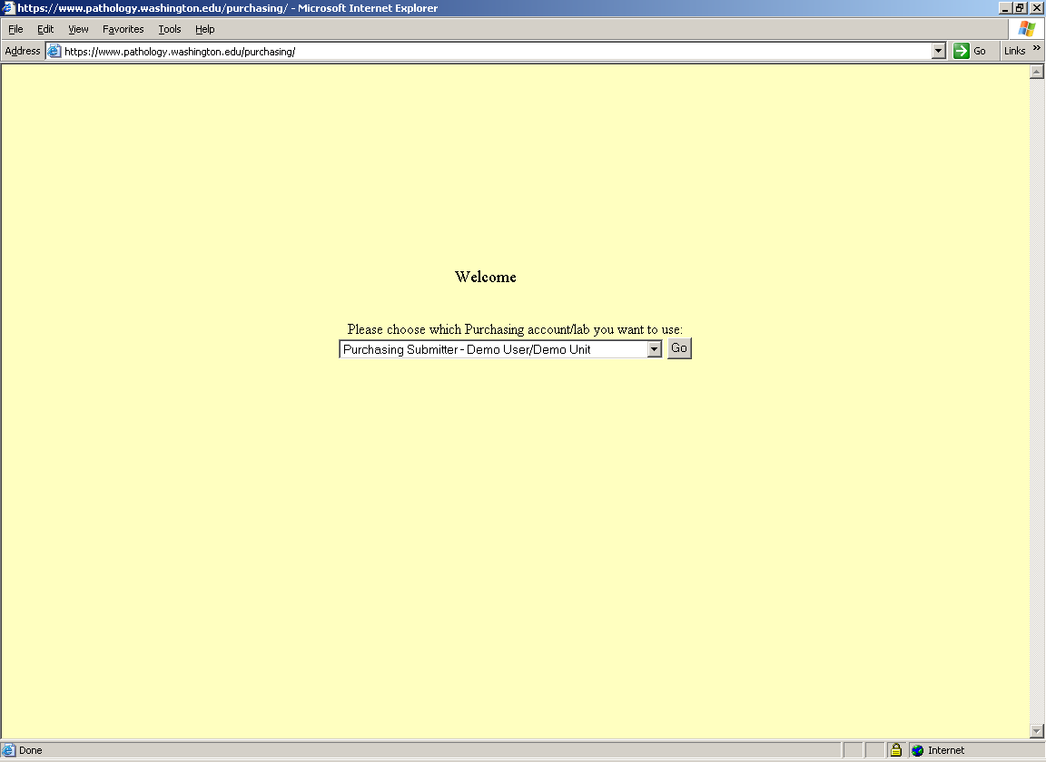

Navigating the Purchasing System
Throughout the purchasing system there is a navigation bar across the top of the page. The navigation bar contains tabs for each major section of the software, a status bar showing your login information, and a quick search feature.

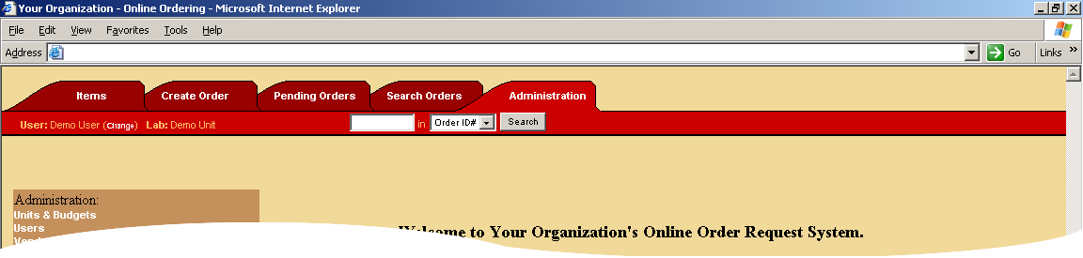

Navigation Tabs
There are five navigation tabs representing each of the major section of the purchasing system. They are:
- Items Management – Manage items that you have purchased in the past and your product database. This includes editing, updating, adding, inactivating, and re-ordering products.
- Create Order – This tab allows you to create an order by first specifying the order type & the vendor and then adding line items to the order.
- Pending Orders – This tab shows you a list of all the orders that you currently have pending. This includes orders you have yet to submit, orders you already submitted, and orders that have been completed by purchasing, but not closed by you yet.
- Search Orders – This tab allows you to search all past orders as well as current orders.
- Administration – This tab contains miscellaneous options for administration of the purchasing system.

Quick Search
The quick search feature allows you to search for a particular PO #, Order #, Item Description, or Vendor. For advanced search features, use the “Search Orders” tab.

Creating orders
There are two ways a user can place an order: by creating a new order or reordering an item from the Item Management tab. See below.

Standard Orders
Standard Orders are usually generic orders that are placed to a particular vendor outside the University and for the most part the “default” order type.

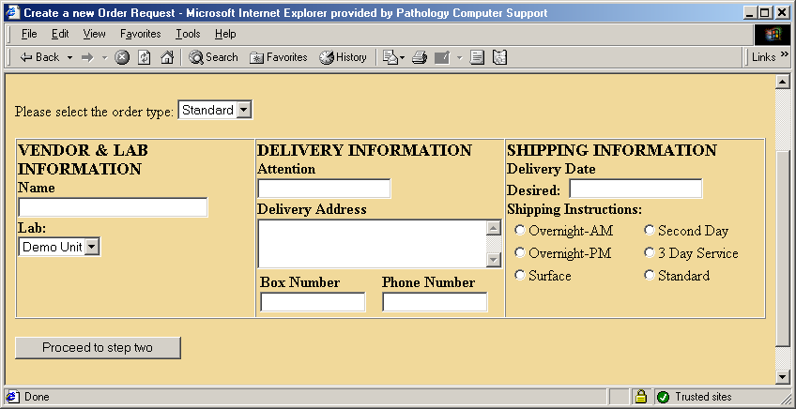

The following information is required for a Standard Order:
Vendor, Address, Phone # | This is the vendor you will be purchasing the items from for this order.
Delivery Attention | Who the order should ship to.
Delivery Address | The address the order should ship to.
Box Number | Box number of the person placing the order.
Phone Number | The phone number of the person to call with questions regarding the order.
Delivery Date Desired | When you would ideally like the order to be delivered.
Shipping Instructions | How to ship the order or are you willing to pay for expedited shipping.

Stores Orders
Stores orders are a special type of order that is directed specifically to UW Stores. Since stores requires different information and a special format for submitting orders you must use this order type for all UW stores orders.

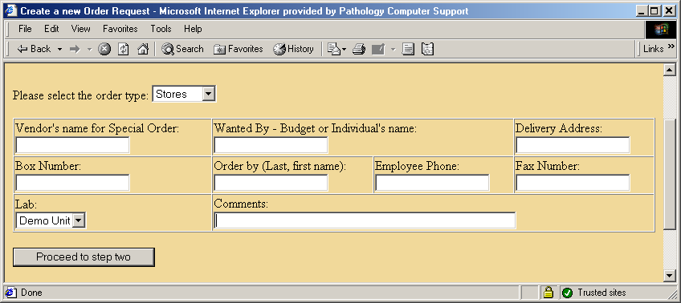
The following information is required for a Stores Order:

Vendor | This is an optional field that is required ONLY if the order is a “Special Stores Order” to an outside vendor through Stores.
Wanted By | The budget number or individual requesting the order.
Delivery Address | Where to deliver the order.
Box Number | Box number of the person placing the order.
Order By | The person who is requesting the order.
Phone Number | The phone number of the person to call with questions regarding the order.
Fax Number | Fax Number of the person placing the order.
Comments | Any comments required on this order.

Radiation Orders
If you are ordering radioactive materials you must use the UW Radiation Order form. This order type collects information specifically associated with radiation orders.

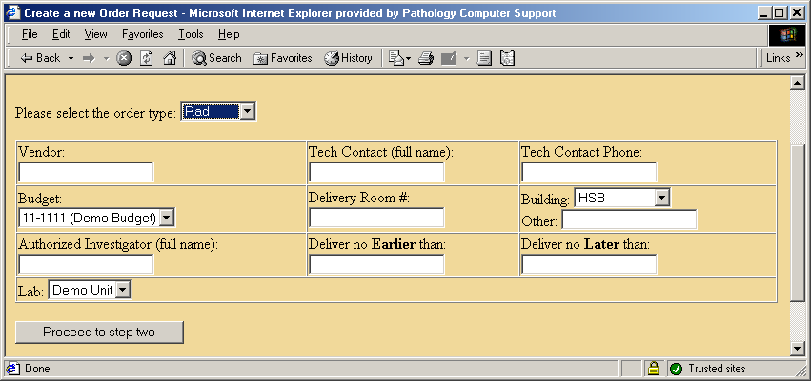

The following information is required for a Radiation Order:

Vendor | The vendor to order from.
Tech Contact | The person who will be using/supervising the radioactive material.
Tech Contact Phone | Phone number of the tech contact.
Budget # | The budget the order will be placed against.
Delivery Room # | The room to deliver the radioactive material to.
Building | The building to deliver the radioactive material to.
Authorized Investigator | The person who is authorized to use this material in their research. They must be on file with Radiation Safety.
Deliver dates | The date range to deliver the material within.

Standing/Maintenance Contract Orders
Sometimes you want to have an automatic repeating delivery schedule contract or maintenance contract order. This type of order has a specific start and end date.

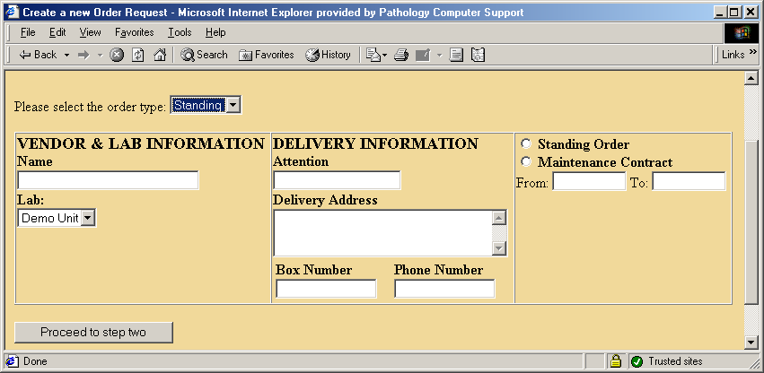

The following information is required for a standard order:

Vendor | This is the vendor you will be purchasing the items from for this order.
Delivery Attention | Who the order should ship to.
Delivery Address | The address the order should ship to.
Box Number | Box number of the person placing the order.
Phone Number | The phone number of the person to call with questions regarding the order.
Standing Order / Maintenance Order | Specifies what type of order it is.
From / To | Specifies the range of dates this order is valid.

Creating Orders Via the Create Order tab
When you click on the Create Order tab you are presented with a screen that prompts you for the order type and is defaulted to showing you the “Standard Order” information. You can choose the type of order you wish to create from the drop-down menu. After filling in the required information, click “Proceed to step two”.

Tip: Not Duplicating Orders
Before creating a new order you should check the pending list to make sure there isn’t an order already started for the same vendor. If there is an order on the pending list that has yet to be submitted, you can add your line item on that order. This will speed up the ordering process and make organization simpler.

Tip: A note on Shipping Information
Please keep the following in mind when you are considering shipping options: When a vendor states “3-5” or “5-7 days” for delivery that means working days, Monday - Friday only. Saturday, Sunday & holidays do not count. Therefore, orders requesting second day air shipment that are submitted on Wednesday and placed on Thursday will be received on Monday. If it is a perishable product that cannot sit over the weekend the vendor may hold the shipment until Monday and you would receive it Wednesday. For orders of non-perishable items submitted on Thursday and placed on Friday requesting second day air you can expect delivery Tuesday, not Monday.

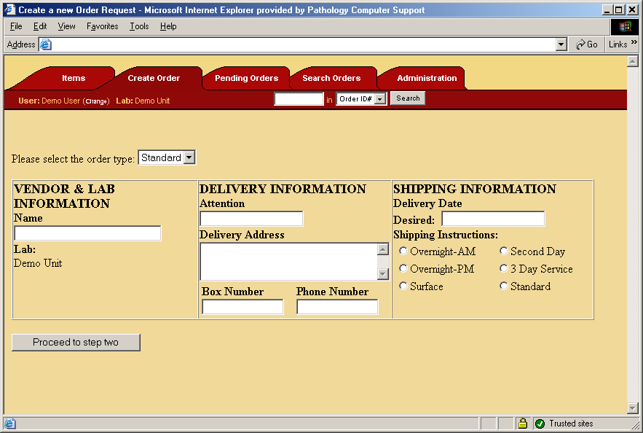

Once you have click “Proceed to step two”, the system will search for the vendor’s name you entered in step one and return a list of vendors that match your search name. Since the system keeps track of every vendor orders have been placed from, the search results are likely to contain the vendor you searched for.

At this point in time you have three options:

- Search Again: If you didn’t find the vendor you wanted, you can search again by modifying your vendor name and click “Go!”
- Choose a Vendor: If the vendor you want to order from is on the list, click the “Use” button next to that vendor.
- Create a New Vendor: If the vendor you want to order from is not in the system, you can add a vendor to the system. To create a new vendor, fill in the information at the bottom to the best of your ability and click “Add”. Make sure to only create a new vendor if it is not already in the system since you can quickly add many duplicate entries into the system.

Tip: Getting the Right Vendor
When selecting a vendor please pay attention to the notes regarding mergers, etc. i.e. 5 Prime, 3 Prime, See Brinkmann Instruments. Please select the appropriate new name that will include the correct vendor address and phone #. This will prevent your order from being delayed.

Tip: Searching for Vendors
Less information in your search criteria will usually yield better results. For example, “bio” will pull up ALL vendors with “bio” in the name. However, “Bio-Rad” will not pull up “BioRad”. The system is not case sensitive but it IS character specific. For example, “Roche” will pull up “Hoffman LaRoche” as well as “Roche Applied Science” (formally Riche Molecular Biochemicals). However, “Roche Molecular Biochemicals” will NOT pull the correct vendor by it’s new name. By using a shorter search criteria you increase your chances of finding what you are looking for.

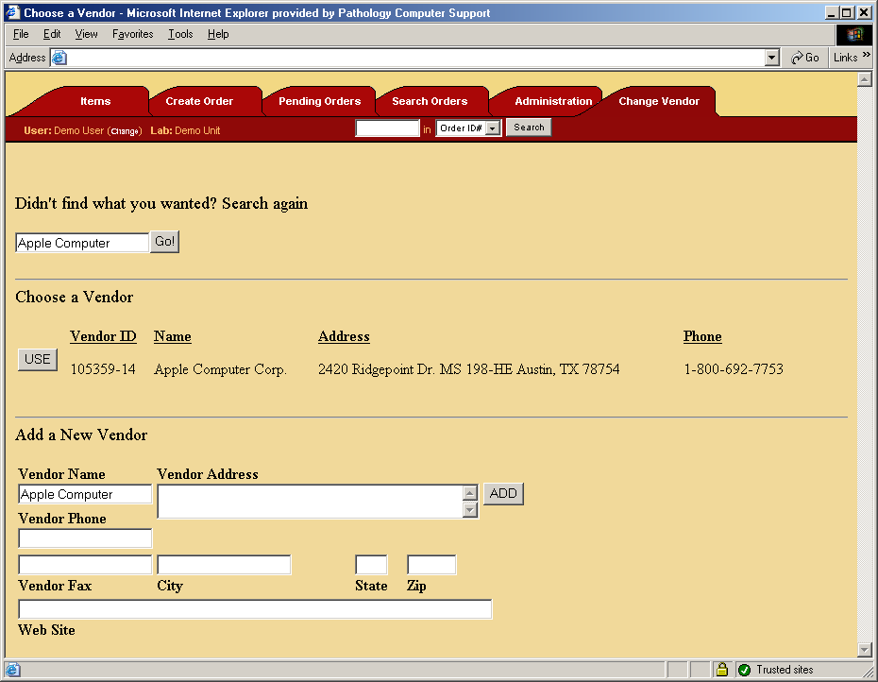

After you have created a new vendor or chosen one to use, you will be finished with the process of creating a new order. The next step is to add line items to the order you just created. For information on adding line items, see section on editing an order.
Creating an Order by Reordering an Item
The other way you can create a new order is by reordering an item that you have purchased in the past. To reorder an item, go to the “Items” tab in the system and search for the product you wish to reorder. For more information on using the “Items” tab see section .

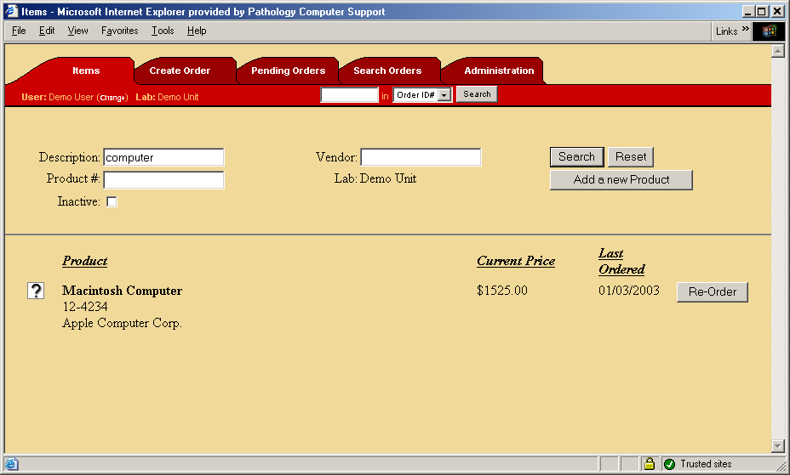

Once you have found the item you wish to reorder, click the “Reorder” button. You will then be prompted to fill in additional information about the item you wish to order. For more information on the data you are required to enter into this window, go to section . When you have finished entering the additional data, you will be returned to the Items management screen. However, your order has been created and is viewable on the Pending Orders tab. Information on the Pending Orders tab can be found in section Error: Reference source not found.

Tip: Benefits of Reordering an Item
Creating an order by reordering an item has some useful advantages over the traditional method of placing an order presented in section . They are:
- Automatic consolidation of orders. If you choose to reorder an item and there is already an order created for the same vendor and that order has not been submitted for purchase then the item you wish to order will be automatically appended to the order. In effect, the system intelligently consolidates orders so that don’t submit separate orders to purchasing thus minimizing your shipping charges as well as the time & effort in tracking and receiving your orders.
- Allow you to take an item oriented approach to ordering. Rather than determining the proper vendor and creating an order, you can instead work off a list of items you need to order, search for those items, and then reorder those items. This is often a more natural way to work since you most likely know the item you want, but not the vendor.

Order Submission
Once an order is ready to be placed it is submitted to the division level purchasing users. At this point in time unit level users can only view the order and are not allowed to make any additional modifications.

Order Approval
If required, an optional approval stage can be added that requires a division administrator to approve an order before it is placed. Once a division administrator reviews an order, they can move it to the approved stage.

Order Purchase Completion
Once an order has been submitted and optionally approved, the order is free to be purchased by the division level purchasing agents. The purchasing agent contacts the vendor, places the order, and updates order information such as the PO #. When the purchasing agent is finished with the order, they move the order to a completed stage. Once moved to the completed stage, the order is back in the control of the unit level users.

Order Receive
When a unit receives the items ordered the mark them as received in the system. Once all items are received the order enters the order-received stage.

Order Closed
When everything is finished within an order and all items are received, the order is then moved to the closed stage. All orders in the closed stage are accessible via a history search.

Pending Orders
The Online Purchasing System allows users to view the status of Pending Orders via the pending orders tab. Pending orders are all orders that have been created and not yet closed. This includes orders that have yet to be submitted to purchasing, those that are being processed by purchasing, and those which have been completed by purchasing. Users also have the option to perform different operations on orders on the pending list.
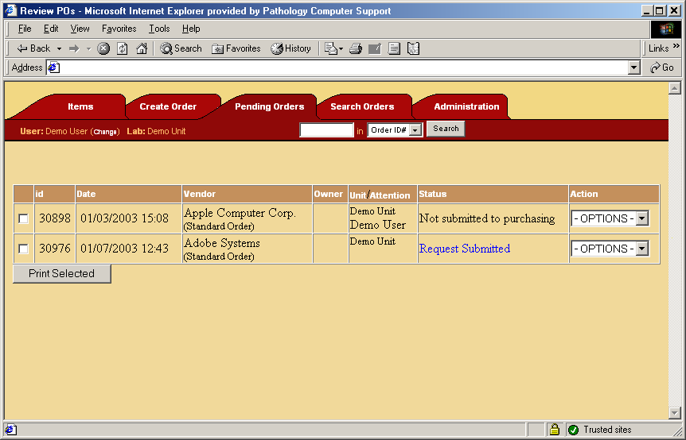

Options on a Pending Order for Unit Members
Users can use the edit option if they have yet to submit the order to purchasing. Editing an order allows users to add, modify, or remove line items, update order wide information, and submit the order to purchasing. For information on editing an order please see section Error: Reference source not found.

Once order requests are submitted to purchase, users no longer have the option to edit their order. However, they do have the option to view the order or print a copy of it. Viewing the order gives additional information that is filled in by the purchasing agent.

When the purchasing agent is finished with the order, the status will change to waiting on items to be received. At this point in time, you can view the order and mark items as received. When you are finished receiving the order, you can choose to close the order. When an order is closed, it is considered finished but can always be retrieved by searching for it. For more information on searching see section .

Tip: Remember to close orders
This will remove the order from the pending list, making it easier to track orders that are still active. The information from the closed order will still be recorded and stored by the system and can be used to create future orders and reorders.

Pending Orders Tab for Purchasing Agents
[This section is for division level users only]

If you are a purchasing agent, the pending orders tab has many more options and also a different view. Purchasing agents have three different views on the pending order tab:
- My Orders – Orders that you have claimed. By claiming an order you indicate that you will be the primary person responsible for placing the order and completing the order.
- Unclaimed – This shows orders that have not been claimed by any purchasing agent. This is where a purchasing agent can look for orders no one has started working on and claim ones that they will work on
- All Orders – This shows all the orders currently pending for purchase.

In addition to having different views, purchasing agents also have more options to perform on an order. In addition to the options outlined above, a purchasing agent can also claim an order, delete an order, complete an order, or throwback an order.

Editing an Order
After you have created an order, you can edit the order to modify line items and the general order information. The edit order tab is visually different for the different types of orders, but functionally it works the same.

To submit an order, click the “Submit this order request” button. This will submit the order to division purchasing agents to be purchased or to a division level manager to approve the order. Note that by submitting an order you will have requested the purchase and will no longer be able to edit the order. You can, however, view the order at any time or contact your purchasing agent to request the order be rejected for correction or additions.

The edit screen also allows you to add, remove, or change line items for that order. To add a new line item, click the “Add a new item” button. To edit a line item, click the “Edit” button next to the line item you want to change. To delete a line item, click the “Del” button next to the line item you want to remove. Please note that if you are a purchasing requester, you will only be able to edit and delete line items you created.

Tip: Saving header information
If you update any information in the header of the order, be sure to click the corresponding “Save” button in the SAME box as the information you changed.

Below is an image of the edit order page showing a standard order?

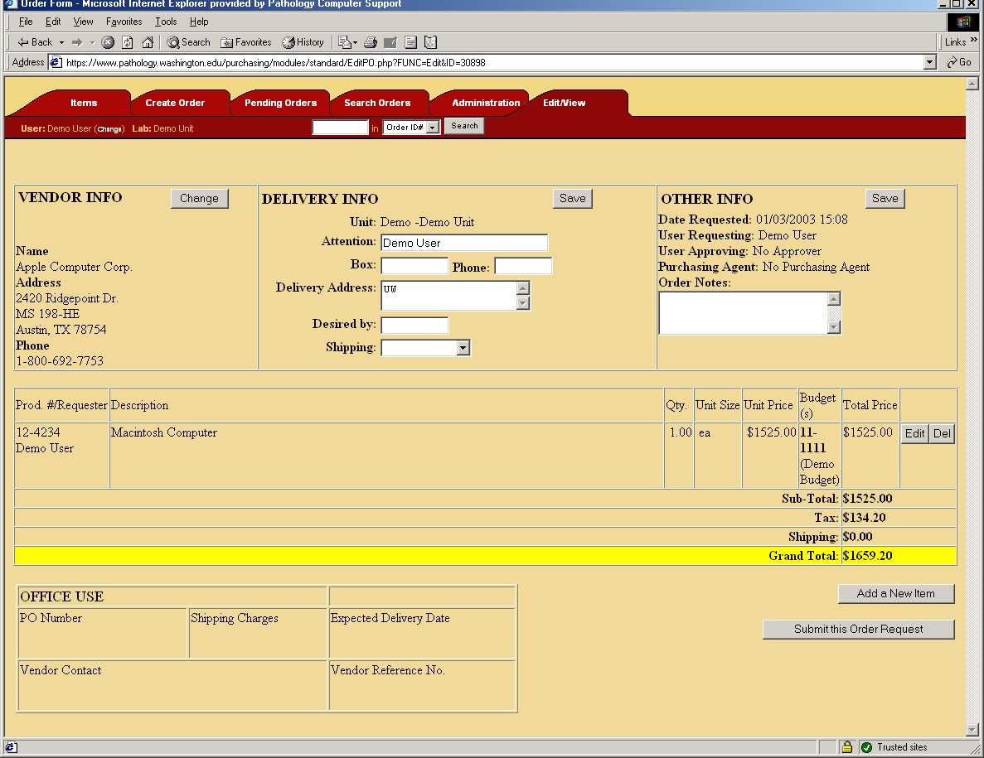

Quotes & Notes
For orders that have written quotes please note the quote # in the notes field in the order header and forward a copy of the quote to your appropriate finance office either via mail or fax. Make sure to note the method of delivery in online order notes. If it is a verbal quote please state “verbal quote #______” in the notes section of the order.

Sole Source Justification
If an order is over $3000 the system will automatically present a new field asking for a sole source justification. You may fill in a justification here or add notes to this field indicating how you will be submitting the sole source to the purchasing agent.

Adding a Line Item
When you click the “Add a new item” button on the edit order page you will be presented with a popup window asking you to search for an item. The following outlines the steps required to add a line item.
- Search for a previous product – You will be prompted to find a product from your past product database first. Enter in the description and/or the product # and click “Go!”
- Results screen – Once you click “Go!” you will be presented with a list of items that match your search. This will be a list of products that you have ordered in the past from the vendor the order is to be placed with. At this point you can click “Choose” next to the item to order it or if your item is not on the list you can add a new item by filling in the fields at the bottom and clicking “Add”.
- The next screen asks you for the quantity, unit size, unit price, budget(s) to order against, the type of product, and any notes you may wish to add. This screen is covered in depth in the next section.
- When you have entered all the information, click “Add item to purchase request”. When you click this button, the popup window will go away and the edit order page will be updated to show your new line item.

Editing a Line Item
After you have completed adding a product or when you click “Edit” next to a line item on the edit order page, you will be presented with the Edit Line Item popup. This popup will allow you to change the quantity, the unit size, the price, the budgets, the product category, and the notes associated with this line item.
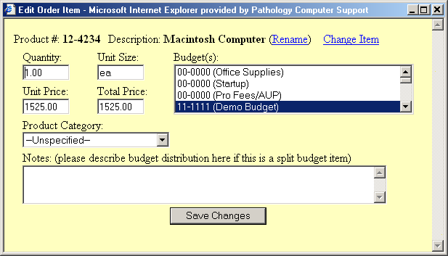
The total price will be calculated automatically as you enter the quantity and unit price. The user can also click “Rename” next to the description to rename the product (if the name has changed from the past) or they can click “Change Item”. By clicking “Change Item” you will be taken through a process to search for a new product, very similar to when you add a new line item.

Tip: Using the Notes Field
The notes field can be very useful to communicate with the purchasing agents. For example, you could paste in a web site address into the notes section to provide the purchasing agents with additional information. Or you can provide detailed notes on who the item is for, special requests, etc.

Tip: Using multiple budgets on purchases
The On-line Purchasing System is designed to allow users to divide the cost of purchases among multiple budgets. To do this hold down the control key and click on each appropriate budget. Then indicate the percentage distribution in the "notes" section for that line item.

For orders that are shared between labs the primary lab may submit the order on-line indicating the budget distribution with other lab’s budgets. However, the division purchasing people will need to receive e-mail authorization from the remaining labs for their portion of the order before the order will be placed. Authorization should be sent to: purchasing@pathology.washington.edu

Items Management
As you place orders, items are automatically added to your product database. The items tab allows you to search your product database and pull up information on products.

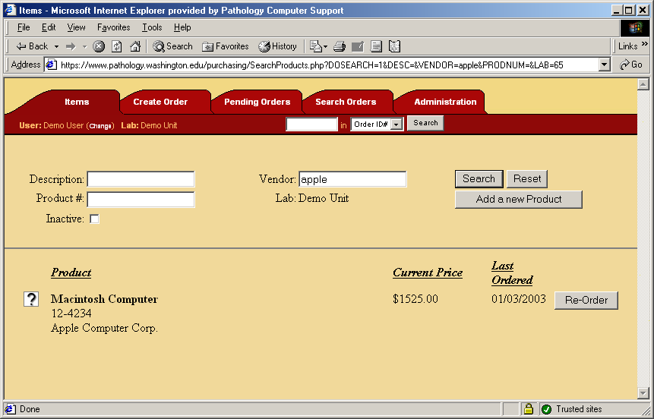

You can search for items based upon the vendor, description, product number, and whether or not the item is inactive. If you choose to search on two or more items, the system will return only the items that match ALL the criteria you choose to search on. You can also do partial searches. For example, searching for “Computer” in the Vendor box will return “Apple Computer Corp” because the vendor’s name contains the word “Computer”.

Tip: Inactive products
If you are searching for a product and it doesn’t come up, try checking the “Inactive” box. The product you are searching for may be inactive. An inactive product is a product that should no longer be ordered. For example, if the vendor stopped carrying the product the product should be set to be inactive.

When you have completed your search you will be shown a list of products. The list shows you the last price the product was purchased at and the date the product was last ordered. If you click the “Re-Order” button, you will create a new order with this product. See section for more information on reordering products.

If you click the icon to the left, another window will popup allowing you change the product and view order history. This is covered in the next section.

Editing a product
When you click icon next to a product on the Items tab, you are presented with a screen that allows you to edit the product. When you change this information it is global to all orders that contain that line item (with the exception of the product’s price). That means that the changes will be shown in all your past orders as well. You should only change this information if it is an actual change information for the same product. For example, if a vendor changes the name of a product they sell, but it’s the same product then it would be appropriate to update the product database. On the other hand, if you should not change the product description from being an apple to an orange.

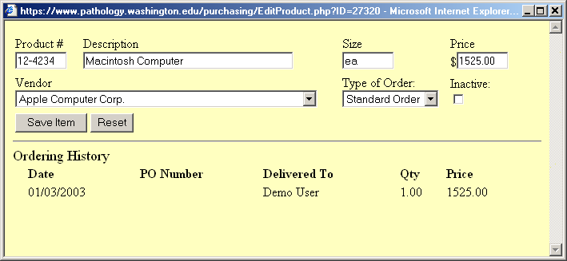

Another feature of this window is that is shows a complete order history on the product.

Searching Orders
You can search your current and past orders from the search tab. This page offers many different things to search on in order to find the order you are looking for. If you search with more than one criterion, the search results will show only the items that match ALL the criteria you specified.

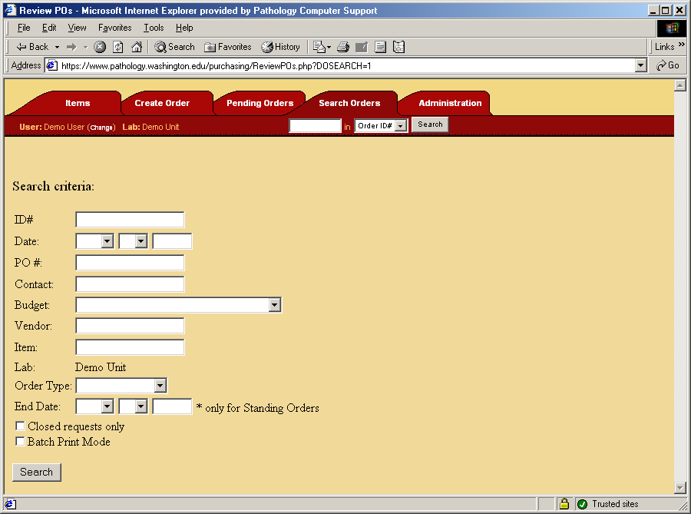

If you specify to “Batch Print Mode”, the orders will be displayed as a PDF file that allows you to print out all the orders that match that criteria easily. If you specify a budget all orders that contain at least one item that contains the budget you are searching for will be returned.

The date field represents the date the order was placed. If you leave any part of the date it is assumed to mean all values. For example, if you search for May 12, and leave the year blank, the system will return all purchases in May 12, regardless of the year
.
Once you have executed the search you will be presented with a screen showing your search results. The results screen has the same layout of as the pending page (section ) with the exception of a total cost computed at the bottom of the page.

Tip: Using the searches for reporting
You can use the search feature to help you generate simple reports. For example, if you are interested in how much you unit has spent in the month of May, you can search for orders in May and get the total purchase amount. Searching for the month of May in addition to a particular vendor or item can further refine a report.

